

Special Overview
The Humanitarian Condition in Gaza Strip
May 2010

Introduction:

- Since Hamas seized power in the Gaza Strip, it has politically institutionalized radical Islam in Gaza. Hamas, supported and funded by Iran, denies Israel's right to exist and continues to build up its weapons stockpiles so as to continue attacking the Israeli civilian population. Since 2010, 140 rockets and mortars were fired at Israel from the Gaza Strip.
- Hamas uses all means available to smuggle weaponry into Gaza. Whether they are using smuggling tunnels or fisherman boats, Hamas is constantly trying to smuggle in missiles, launchers, guns, explosives and materials for building weapons.
- IDF operations in the Gaza Strip, including the maritime closure and crossing restrictions, arise from the need to maintain the safety of the citizens of Israel from the terrorist threat in the Gaza Strip and to prevent weapons smuggling.
- The Ministry of Defense and the IDF allow the crossing of goods and equipment in a routine and frequent manner, and enables the transfer of people for medical, religious, welfare, business or diplomatic reasons.
- This summary provides facts and figures, which contravene the claim of a "humanitarian crisis" in the Gaza Strip.
Food Products and Clothing:

- Most types of food are allowed into the Strip, and are transferred by the private sector or by international organizations.
- During 2009, 30,920 trucks containing 800,000 tons of supplies were transferred into Gaza. This included fruits and vegetables, meat products, poultry and fish, dairy products, sugar, rice and legumes, flour and yeast, oil, and more. Furthermore, 10,871 heads of cattle were transferred for the Muslim holidays of Ramadan and Eid al-Adha.
- In the first quarter of 2010 (January-March), 94,500 tons of supplies were transferred in 3,676 trucks to the Strip: 48,000 tons of food products; 40,000 tons of wheat; 2,760 tons of rice; 1,987 tons of clothes and footwear; 553 tons of milk powder and baby food.
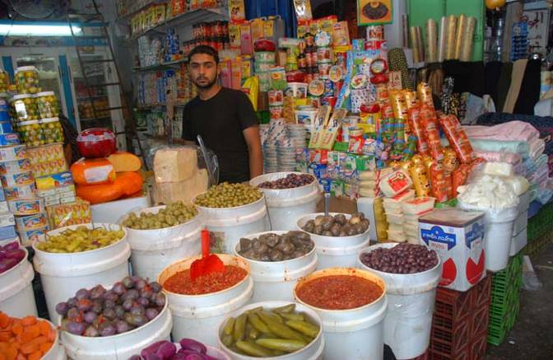
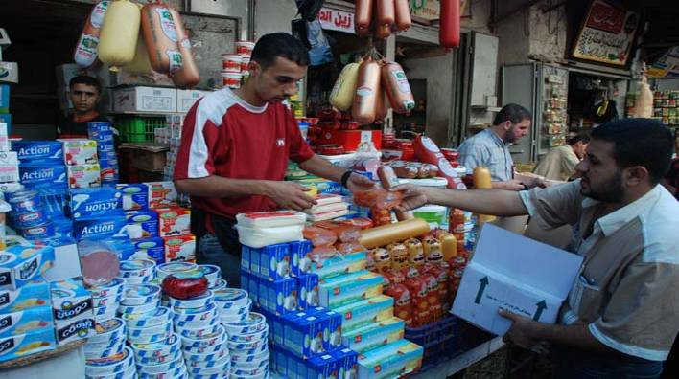
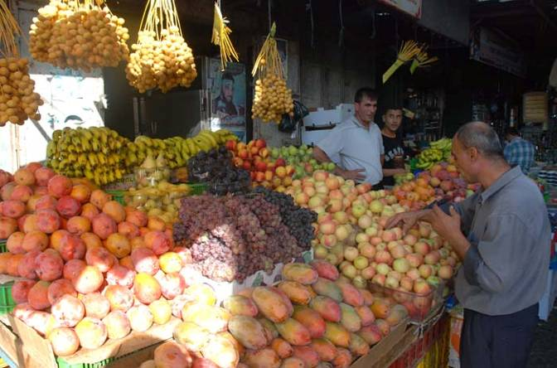
Pictures of the Gaza market, taken from the Palestinian website "Palestine al-Yom."

שוק עזה, נובמבר 2009
תמונות מהשוק בעזה, לקוח מתוך אתר החדשות הפלסטיני "Palestine alyom".
- In 2009, 572 trucks containing approximately 5,000 tons of medical supplies entered the Strip.
- In the first quarter of 2010 (January-March) 1,068 tons of medicine and medical equipment were transferred in 152 trucks.
- In 2009 two elevators were transferred to hospitals in Gaza, as was a CT imaging system (to the Red Cross hospital), and equipment for a mammography machine (which checks for breast cancer).
- During the first quarter of 2010 four trucks with special supplies for a project of the "Al Quds" hospital were transferred to the Gaza Strip, and an additional 13 trucks are scheduled to cross.
- Due to fears of a swine flu outbreak, three Israeli hospitals were assigned to treat cases in the Gaza Strip and 44,500 immunizations were transferred to the Strip.
During 2009, 10,544 residents along with 12,000 accompanying individuals were transferred Israel to receive medical treatment. Likewise, there were 382 emergency evacuations from Gaza for medical purposes.

Equipment for Essential Civilian Infrastructure:

- 14) Throughout 2009 Israel transferred 41 trucks of equipment for the maintenance of the electricity grid, and the state continues to provide approximately 60% of Gaza's electricity.
- 15) In 2009 over 105 million liters of fuel were transferred to Gaza's power plant and over 3.2 million liters of gas were transferred for UNWRA operations.
- 16) In 2009 127 trucks containing more than 3,000 tons of hypochlorite entered the Gaza Strip for water purification purposes. Moreover, 48 trucks of equipment for improving the sanitation infrastructure led to a substantial reduction in the Beit Lahya facility's waste levels.
- 17) As part of the preparations made for winter, 3,607 tons of glass were transferred to the Gaza Strip. According to UN reports, windows in all education and health institutions were repaired.
- 18) In the first quarter of 2010 Israel transferred:
  - 250 trucks with equipment for the UNWRA summer camp, including: Arts and crafts equipment, swimming pools, inflatable toys, ice cream machines, musical instruments, clothing, sports equipment, etc.
  - Seven trucks with equipment for upgrading the sewage pumping station, which was carried out by UNWRA.
  - 74 empty containers for UNWRA for use in classrooms and bathrooms
- 19) Certain types of materials, such as cement and iron, are more restricted. These products are openly used by Hamas for developing its arsenal, building bunkers and launching sites, and making rockets and mortars.
- 20) Despite the risk, the transfer of these items is also permitted under supervision, once it has been cleared that these materials are for civilian purposes only. Already in the first quarter of 2010, 23 tons of iron and 25 tons of cement were transferred to the Gaza Strip.
According to UN figures, updated as of 30 January 2010, about 78% of houses lightly damaged in the Gaza Operation have been repaired.

Movement of Residents in and out of the Gaza Strip

- Despite the inherent dangers involved, Israel permits Gazans and visitors to travel between Gaza and Israel, from Gaza to Judea and Samaria, and even abroad for medical treatment, religious pilgrimages, and business trips. Whenever possible Israel allows for diplomatic activities and trade and commerce with the Gaza Strip.
- Here are a number of examples from 2009:
- Delegations from abroad: 21,200 activists from international organizations from over 400 diplomatic delegations were permitted entry into Gaza, and 2,200 Palestinians employed by international organizations were given exit permits from the Gaza Strip.
- Education, Vacations and Pilgrimages to Holy sites: 147 permits were given to Palestinian students for academic studies around the world. During the Christmas holiday approximately 400 permits were given to visit Bethlehem from Gaza as well 100 permits to travel abroad.
- Business: 257 permits were given to businessmen from Gaza to facilitate business operations.
- Sports: Special permission was given to Gazan footballers to train in Judea and Samaria and compete in international matches abroad.

Trade and Commerce
During 2009 7.5 million tons of flowers and 54 tons of strawberries were exported from Gaza.

- Israel has taken measures to support trade and commerce, the banking system, and the existing financial market in the Gaza Strip:
- In 2009 1.1 billion NIS was transferred to the Gaza Strip for the ongoing activity of international organizations and to pay the salaries of Palestinian Authority workers.
- 40 million damaged bank notes were traded for new bills, and at the request of the Palestinian Monetary Fund, 282.5 million shekels were transferred from Gazan to Israeli Banks.
- In February 2010 an agreement was reached with the Palestinian Authority's National Insurance Department to ensure that pensions reached those formerly employed in Israel. The funds were deposited in banks in Judea and Samaria, while the Palestinian Authority was given the responsibility of distributing the funds to the pensioners in Gaza.
Conclusion

- The State of Israel seeks regional stability and to protect her citizens. It is not in the interest of Israel to harm the people of Gaza and the state does its utmost to assist aid efforts, so as not to harm the quality of life for the residents of Gaza.
- Hamas, in its continued efforts to smuggle weapons into the Gaza Strip, harms the people of Gaza and prevents them from further development.
- Despite these security threats, the IDF continues to allow the transfer of commercial goods, building materials, and medical equipment into Gaza.

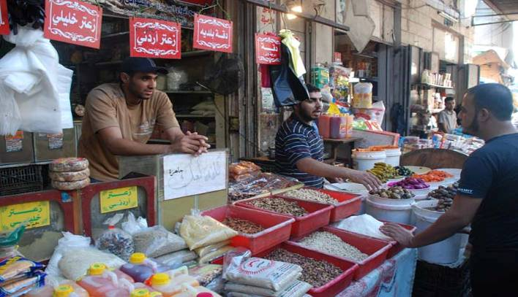

The Gaza City Market, Novemeber 2009
Taken from the Palestinian website "Palestine al-Yom."

